On a N * N grid, we place some 1 * 1 * 1 cubes that are axis-aligned with the x, y, and z axes.

Each value v = grid[i][j] represents a tower of v cubes placed on top of grid cell (i, j).

Now we view the *projection* of these cubes onto the xy, yz, and zx planes.

A projection is like a shadow, that maps our 3 dimensional figure to a 2 dimensional plane.

Here, we are viewing the "shadow" when looking at the cubes from the top, the front, and the side.

Return the total area of all three projections.

**Example 1:**

**Input:** [[2]]

**Output:** 5

**Example 2:**

**Input:** [[1,2],[3,4]]

**Output:** 17

**Explanation:**

Here are the three projections ("shadows") of the shape made with each axis-aligned plane.

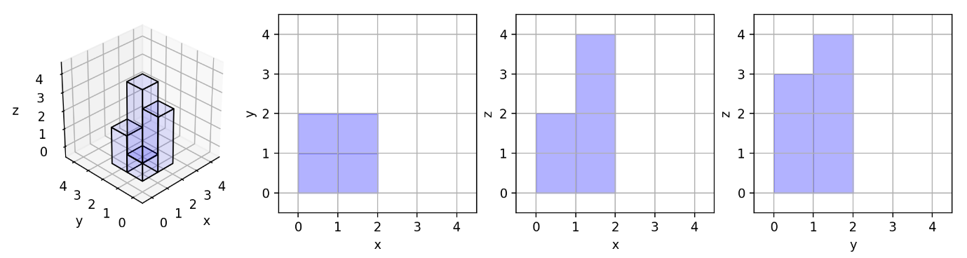

**Example 3:**

**Input:** [[1,0],[0,2]]

**Output:** 8

**Example 4:**

**Input:** [[1,1,1],[1,0,1],[1,1,1]]

**Output:** 14

**Example 5:**

**Input:** [[2,2,2],[2,1,2],[2,2,2]]

**Output:** 21

**Note:**

* 1 <= grid.length = grid[0].length <= 50
* 0 <= grid[i][j] <= 50